[sample bulletin announcement]

Refugee Sunday
As Canada marks the 40th anniversary of Refugee Rights Day (April 4) and the world marks World Refugee Day (June 20), the combined pressures of conflict, global economic and political instability, and climate change have led to an ever-increasing number of refugees and Internally Displaced Persons (IDPs) around the world, all while borders are closing and the “stranger” is increasingly scapegoated. In response, the Acting Primate, Archbishop Anne Germond, invites Anglicans to learn more about the challenges facing those who have been forced to flee their homes. Alongside Hope has gathered educational and worship resources for parishes or individuals to use at alongsidehope.org/Refugee-Sunday.

[sample graphic for social media]

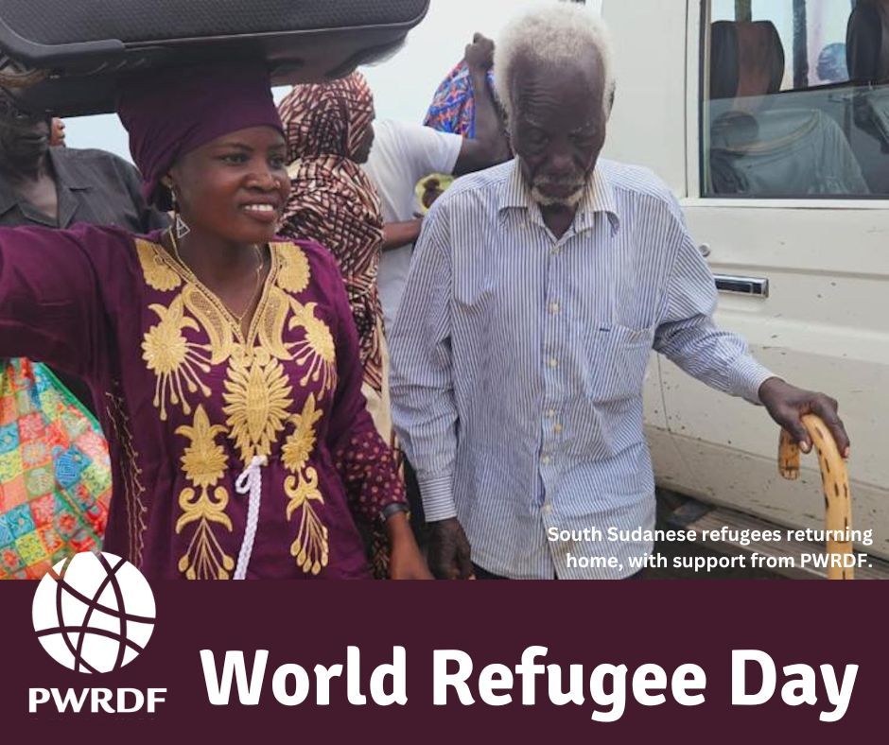

Download the JPEG

